**User Manual:**

Search Engine.java contains the main method of the project.

When the user runs the program the user is greeted with a main page GUI.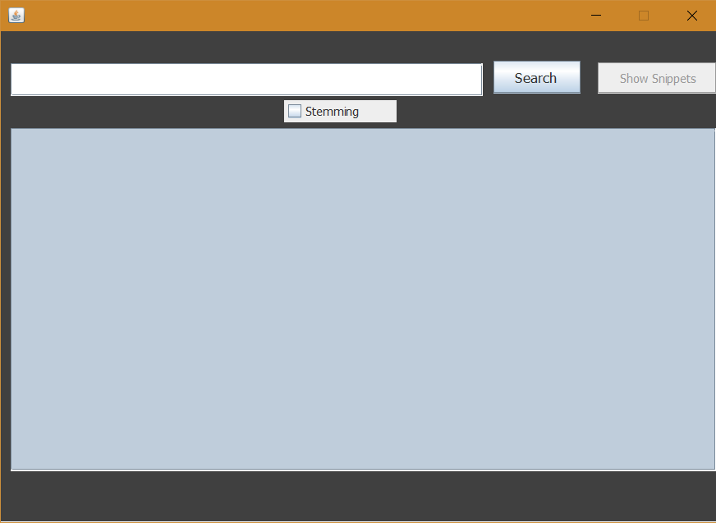

The main page GUI has a text box for the user to type the word user want to search for. There is a search button which triggers the search with the word from the text box. There is a toggle switch for enabling and disabling Stemming. There is also a Show Snippets button which only gets enabled after the user has searched for something.

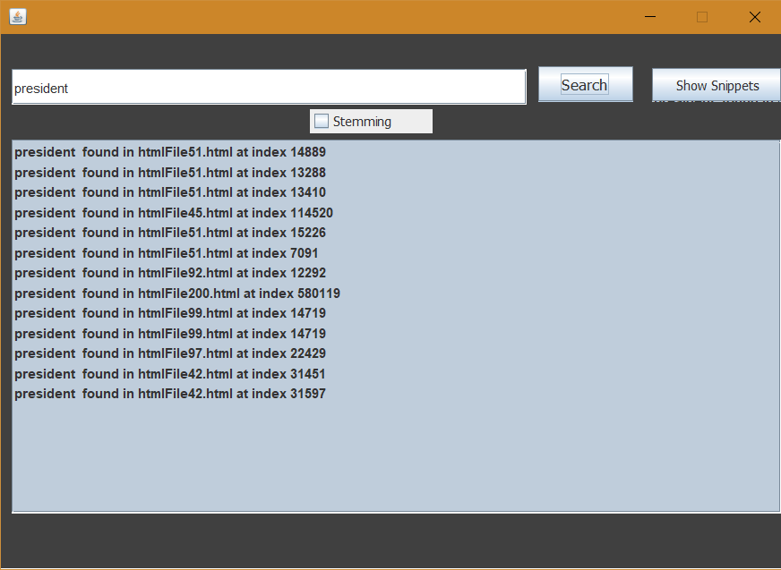

This is an example of a word President that has been searched.

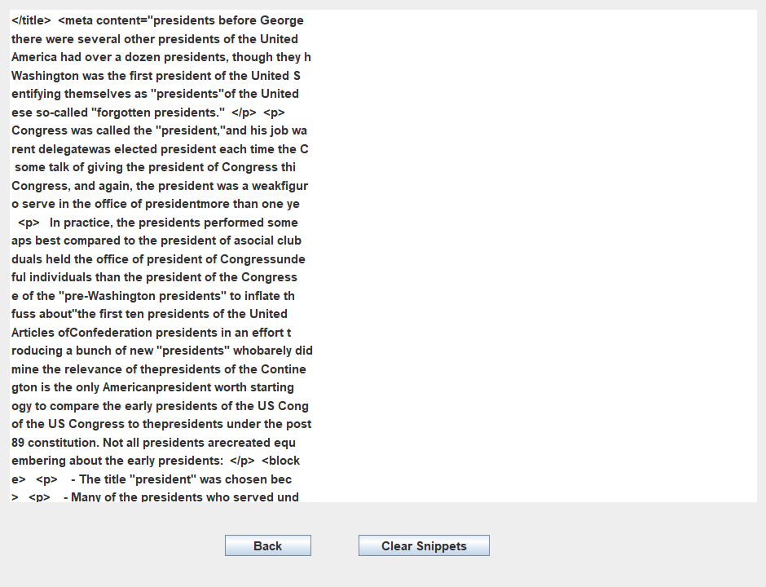

The is the show snippets screen that lets the user see the snippets. There is also a back button to go back to the main GUI and clear snippets button to clear the snippets screen.

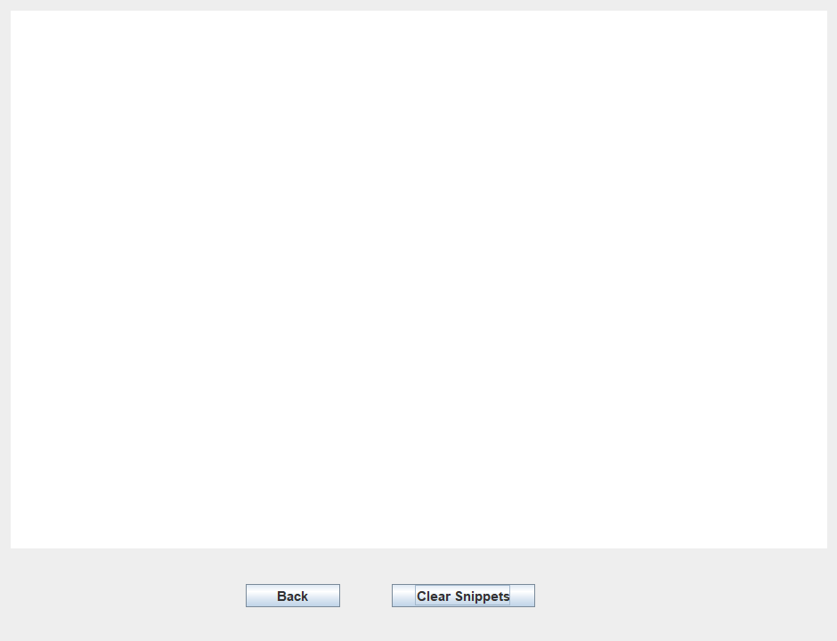

This is how it looks like after clearing the snippets screen.

Some of the most Important Query words are:

President

Justice

Money

River

Population

Territory

Bangladesh